Elastic Container Service
Highly Available ECS Cluster
Final architecture
We'll build this:
Internet
|
|
+----------------+
| ALB |
| Port 80 HTTP |
+-------+--------+
|
+--------------+--------------+
| | |
v v v

Availability Availability Availability
Zone A Zone B Zone C

+---------+ +---------+ +---------+
| EC2-1 | | EC2-2 | | EC2-3 |
| ECS | | ECS | | ECS |
| Agent | | Agent | | Agent |
+----+----+ +----+----+ +----+----+
| | |
+--+--+ +--+--+ +--+--+
| | | | | |
Task1 Task2 Task3 Task4 Task5 Task6
| | | | | |
+-----+----------+-----+----------+-----+
|
sabair0509/hiring-app:works
Each task will listen on the container port, while ECS assigns a different host port dynamically.
For example: EC2-1
Task 1 → container 8080 → host 32768
Task 2 → container 8080 → host 32769
EC2-2
Task 3 → container 8080 → host 32770
Task 4 → container 8080 → host 32771
EC2-3
Task 5 → container 8080 → host 32772
Task 6 → container 8080 → host 32773
The exact host ports will be selected by ECS; don't hard-code them.

Phase 1 — Important requirement
Before starting, we need to know what port the Docker image exposes.
Your image is: sabair0509/hiring-app:works
Let's inspect it first.
From any machine with Docker:
docker pull sabair0509/hiring-app:works
Then: docker image inspect sabair0509/hiring-app:works
Look for: "ExposedPorts"
You may see something like: "ExposedPorts": {
"8080/tcp": {}
}
If you see 8080
We'll use: Container port = 8080
Host port = 0
If you see another port, tell me that port before continuing because the ECS task definition needs to match it.
Phase 2 — AWS infrastructure
We'll create:
VPC
|
+-- Public Subnet AZ-A
|
+-- Public Subnet AZ-B
|
+-- Public Subnet AZ-C
|
+-- Internet Gateway
|
+-- Security Groups
|
+-- ALB
|
+-- ECS EC2 instances
For a learning lab, we can keep the ECS instances in public subnets to simplify the setup.
For production, I'd normally put ECS instances in private subnets and place only the ALB in public subnets.

Step 1 — Check your AWS Region
Use the region you've been using in your previous AWS labs.
For example: us-east-1
AWS Console
↓
Region
↓
N. Virginia / us-east-1
Stay in one region throughout the exercise.
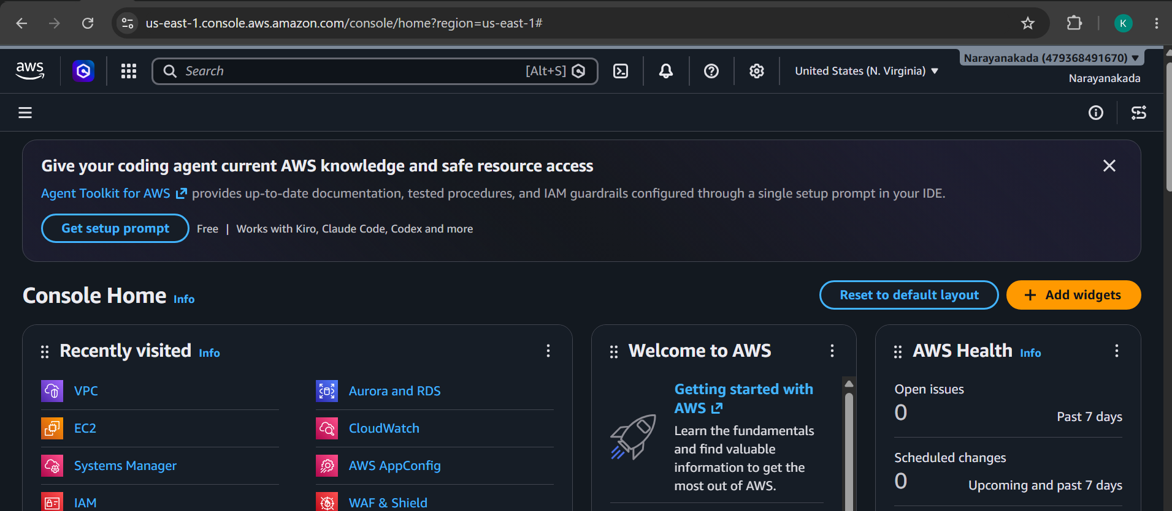Step 2 — Create VPC
Go to: AWS Console
→ VPC
→ Your VPCs
→ Create VPC
Select: Resources to create: VPC and more
Use: Name: ecs-ha-vpc
If we have default VPC we can add subnets to it if we have 2 public subnets then add one more public subnet to same VPC
IPv4 CIDR: 10.0.0.0/16
Availability Zones:3
Public subnets: 3
Private subnets: 0
NAT gateways: None
VPC endpoints: None
Then: Create VPC
You should have: 10.0.0.0/16
with three public subnets.
For example:10.0.1.0/24
10.0.2.0/24
10.0.3.0/24
The exact CIDRs don't matter.Step 3 — Verify the three AZs
Go to: VPC
→ Subnets
You should see three subnets similar to:
public-subnet1
us-east-1a
public-subnet2
us-east-1b
public-subnet3
us-east-1c
Make sure they are actually in different Availability Zones.
This is important.
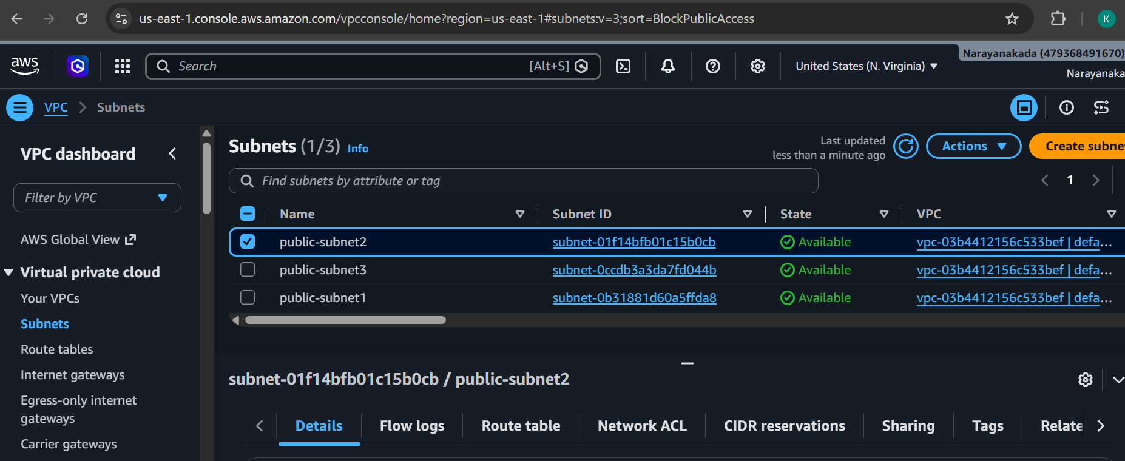

Step 4 — Create ALB Security Group
Go to: EC2
→ Security Groups
→ Create security group
Name: ecs-alb-sg
VPC: default vpc
Inbound rules: HTTP
Type: HTTP
Port: 80
Source: 0.0.0.0/0
For the lab, that's enough.
Outbound: All traffic 0.0.0.0/0
Create. 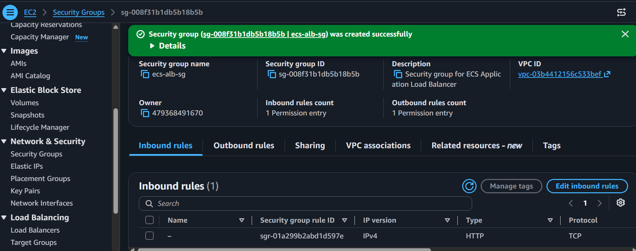
Step 5 — Create ECS EC2 Security Group
Create another security group: ecs-instance-sg
VPC: default vpc
Inbound:SSH
Type: SSH
Port: 22
Source: My IP
Dynamic ECS ports
For this lab, we can allow the ALB security group to reach the EC2 instances.
Create: Custom TCP
Port: 32768-65535
Source: ecs-alb-sg
Depending on the ECS AMI/network configuration, the dynamic port range may differ, so we'll verify the ECS host configuration after launching the instances. AWS documents dynamic host ports using the container instance's ephemeral port range.
Outbound: All traffic 0.0.0.0/0
Create.
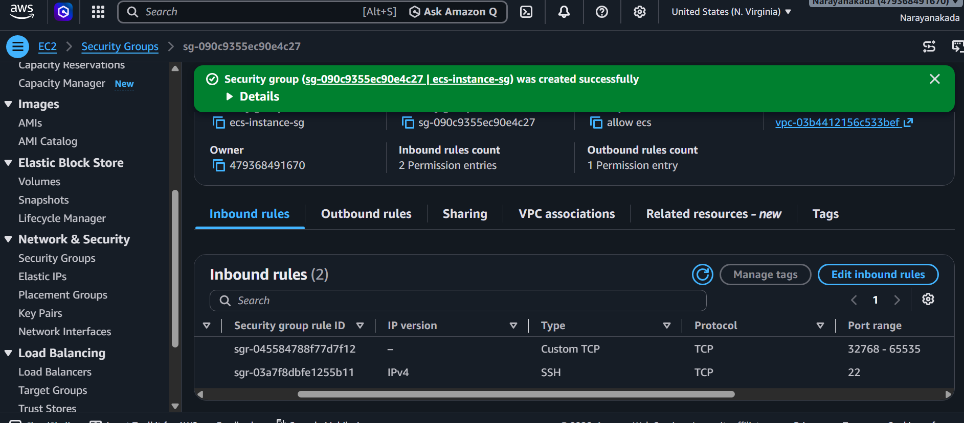
Phase 3 — Create ECS Cluster
Step 6 — Create ECS cluster
Go to: AWS Console
→ ECS
→ Clusters
→ Create cluster
Step 7 — Cluster name
At the top enter: ecs-ha-cluster
So: Cluster name: ecs-ha-cluster
Don't change the Service Connect defaults.
Leave: Default namespace: Blank
We don't need Service Connect for this exercise.
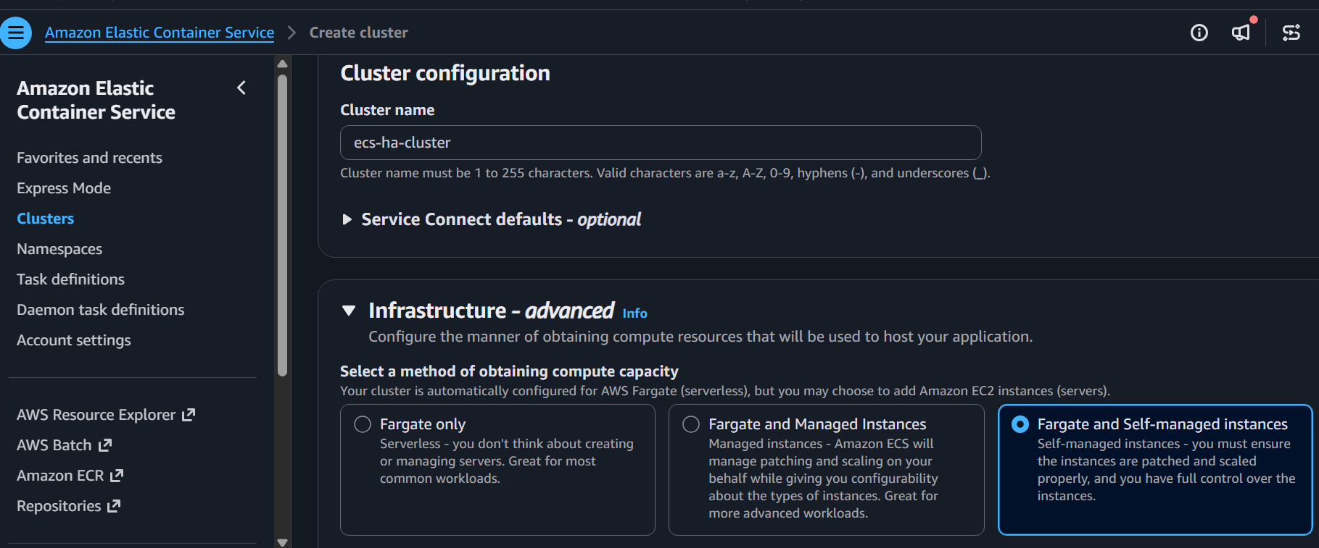

Step 8 — Configure Self-managed EC2 instances
After selecting: Fargate and Self-managed instances
additional EC2 configuration fields should appear under Infrastructure.
You may need to scroll down.
Look for an EC2/self-managed instance configuration section.
We want approximately:
EC2 instance type: t3.small
For this lab, use: t3.small
Why t3.small?
Our eventual target is:6 ECS tasks
and each task will consume some CPU and memory.
t3.micro can become restrictive very quickly.
t3.small gives us a better learning-lab starting point.
Step 9 — Set the EC2 capacity
Look for fields related to: Desired capacity
Minimum capacity
Maximum capacity
Set: Desired capacity: 3
Minimum capacity: 3
Maximum capacity: 3
Our target: ECS CLUSTER
ecs-ha-cluster
|
+------------+------------+
| | |
AZ-A AZ-B AZ-C
| | |
EC2-1 EC2-2 EC2-3
This is important because later we want six tasks distributed across the three AZs.
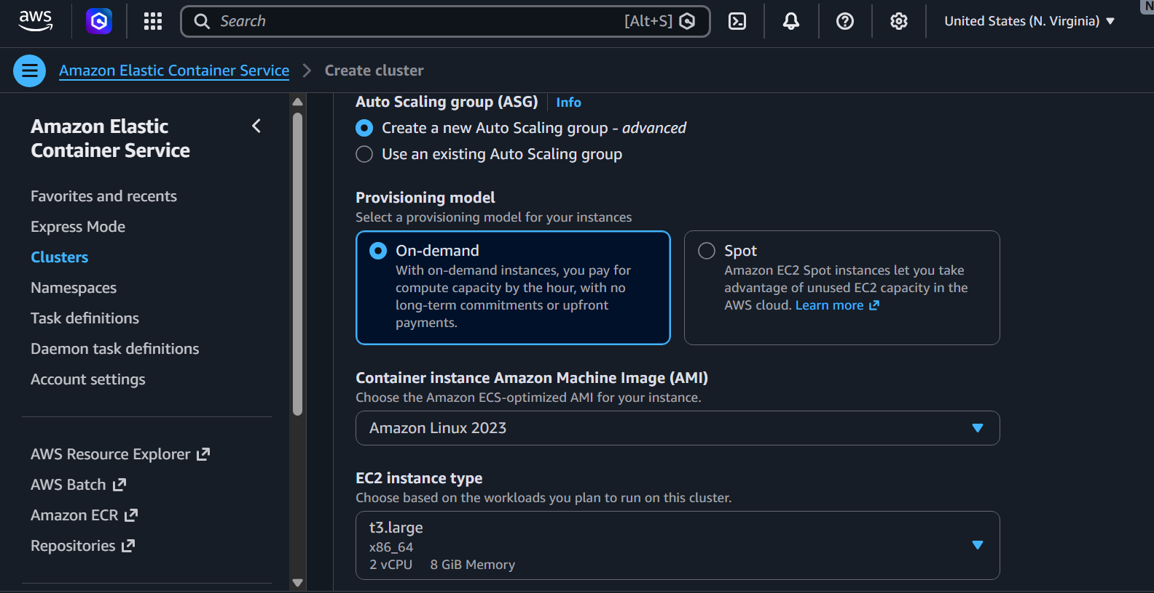
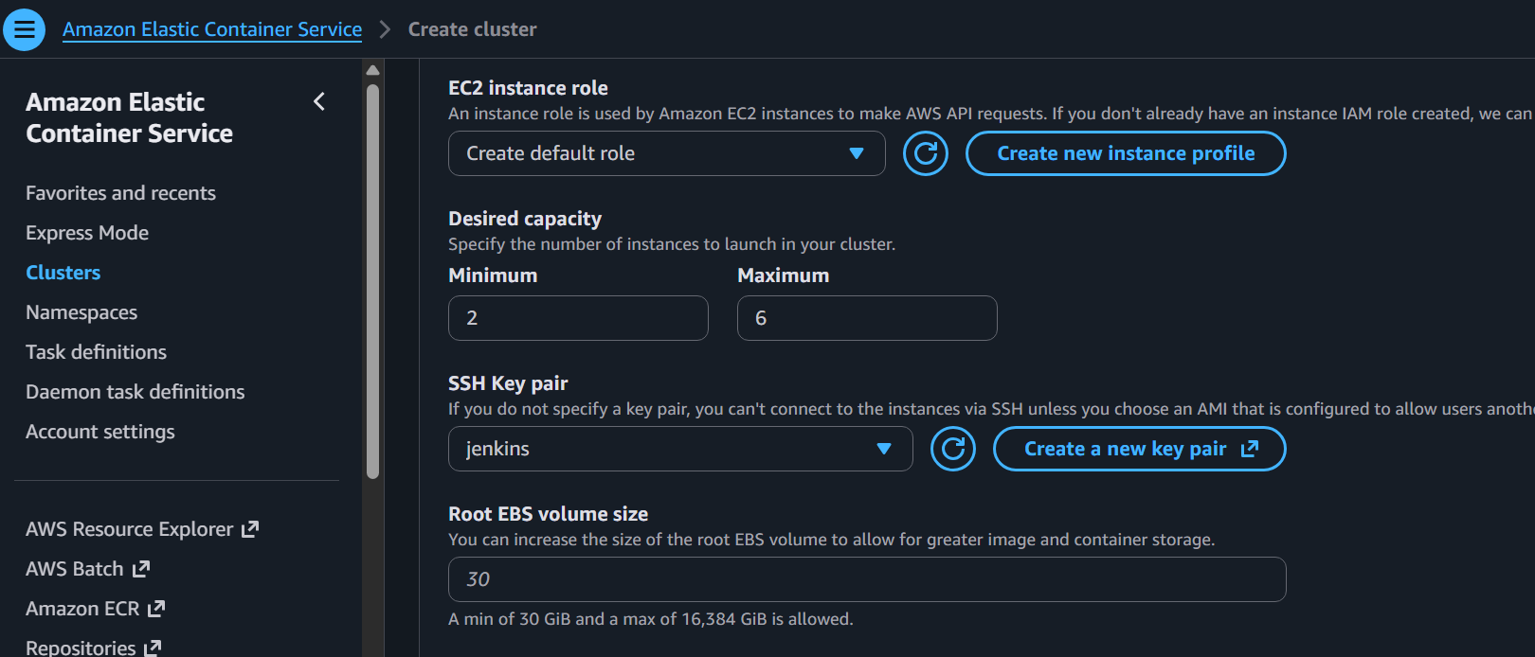
Step 10 — Configure VPC
Look for the networking/VPC section in the EC2 configuration.
Select: VPC: vpc-03b4412156c533bef
This is your existing VPC:10.0.0.0/16
Do not create a new VPC
Step 11 — Select the three subnets
Select all three existing public subnets: public-subnet1
subnet-0b31881d60a5ffda8
us-east-1a
public-subnet2
subnet-01f14bfb01c15b0cb
us-east-1b
public-subnet3
subnet-0ccdb3a3da7fd044b
us-east-1c
Your configuration should look conceptually like:
VPC vpc-03b4412156c533bef
Subnets
☑ public-subnet1
us-east-1a
☑ public-subnet2
us-east-1b☑ public-subnet3
us-east-1c
Very important
Don't select just one subnet.
We need all three: AZ-A
AZ-B
AZ-C
for the HA requirement.
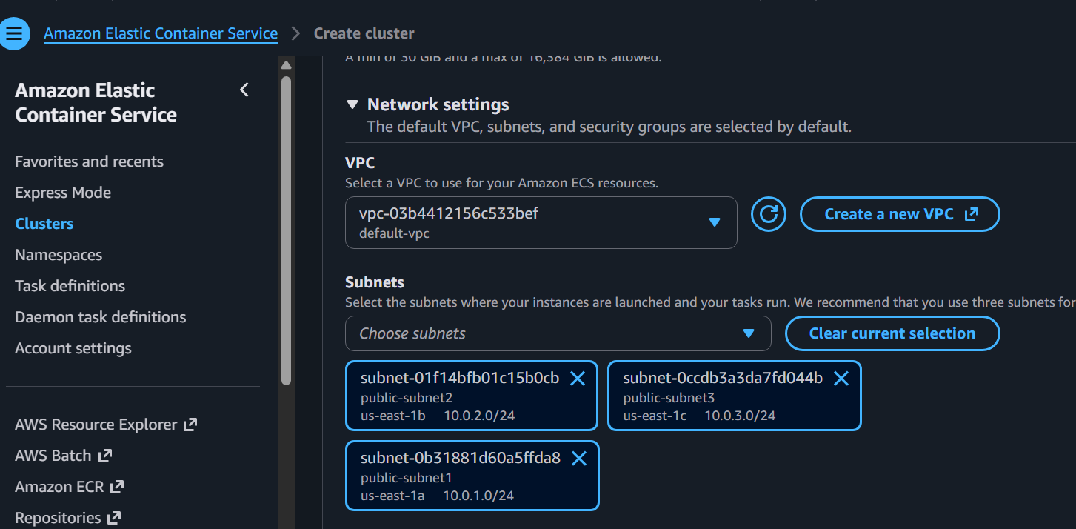
Step 12 — Select the ECS instance security group
Look for: Security group
Select: ecs-instance-sg
Do not select: default sg-0350fdd15e921394c
Our architecture should be:
ALB
↓
ecs-alb-sg
↓
ecs-instance-sg
↓
ECS tasks

Step 13 — Configure public IP
Because we're using your public subnets for this lab, enable: Auto-assign public IP: Enabled
This will allow the EC2 instances to reach the internet directly.
That's useful because the ECS instances need to communicate with AWS services and pull:
sabair0509/hiring-app:works
from Docker Hub.
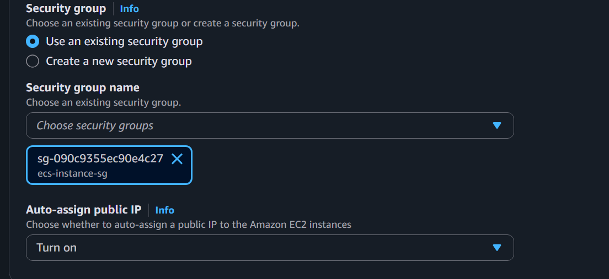
Create the cluster
Now click: Create
AWS will create: ecs-ha-cluster
and provision the self-managed EC2 capacity.
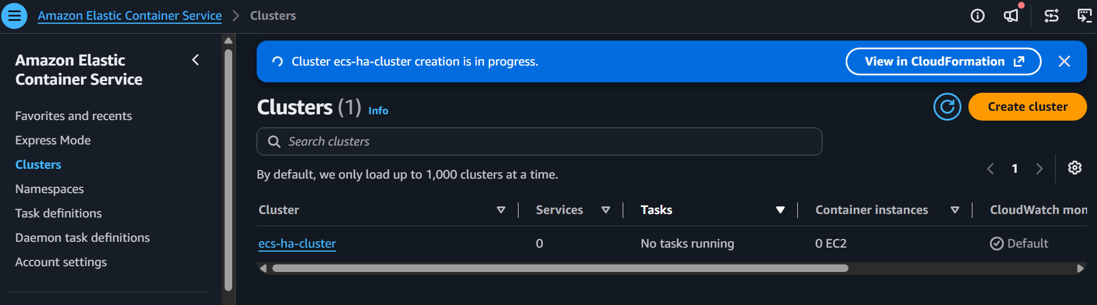
Step 10 — Wait for ECS-managed Auto Scaling Group
Your current screen shows:
Status: Updating capacity
This means AWS is currently trying to provision the EC2 capacity.
Don't modify the ASG yet.
Wait approximately 3–5 minutes, then refresh the Auto Scaling Groups page.
We are looking for:
Instances: 2 or more
and eventually:
Status:
Ready / Stable
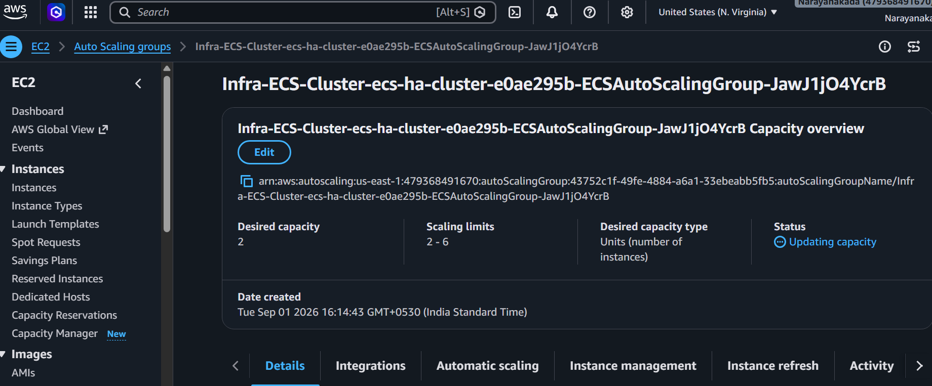
4. Create Application Load Balancer
Go to: EC2 → Load Balancers → Create Load Balancer
Choose: Application Load Balancer
Internet-facing
Select: Public Subnet AZ-1
Public Subnet AZ-2
Security group: ALB-SG
Listener: HTTP : 80
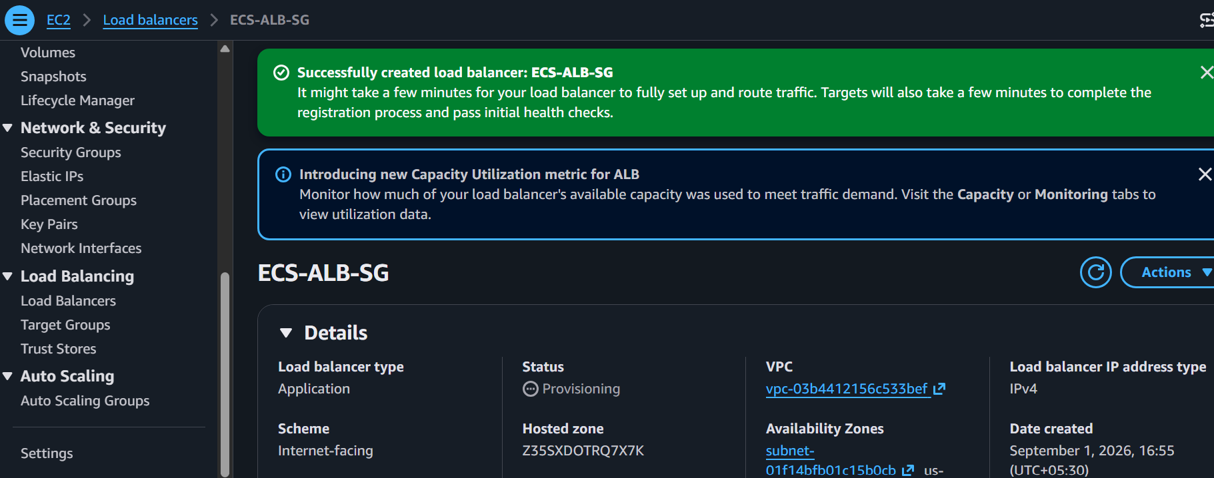
Purpose: ALB distributes user requests across your ECS tasks.
5. Create Target Group
Go to: EC2 → Target Groups → Create target group
Choose: Target type: Instances
Protocol: HTTP
Port: 80
Name:
hiring-app-tg
Health check:
Path: /
Purpose: Target group allows the ALB to find and health-check ECS task targets.
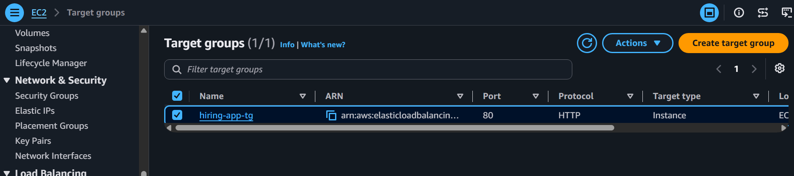
6. Create Task Definition
Go to: ECS → Task Definitions → Create
Name:ECS-cluster-TD
Choose: Launch type: EC2
Add container: Container name: hiring-app
Image:sabair0509/hiring-app:works
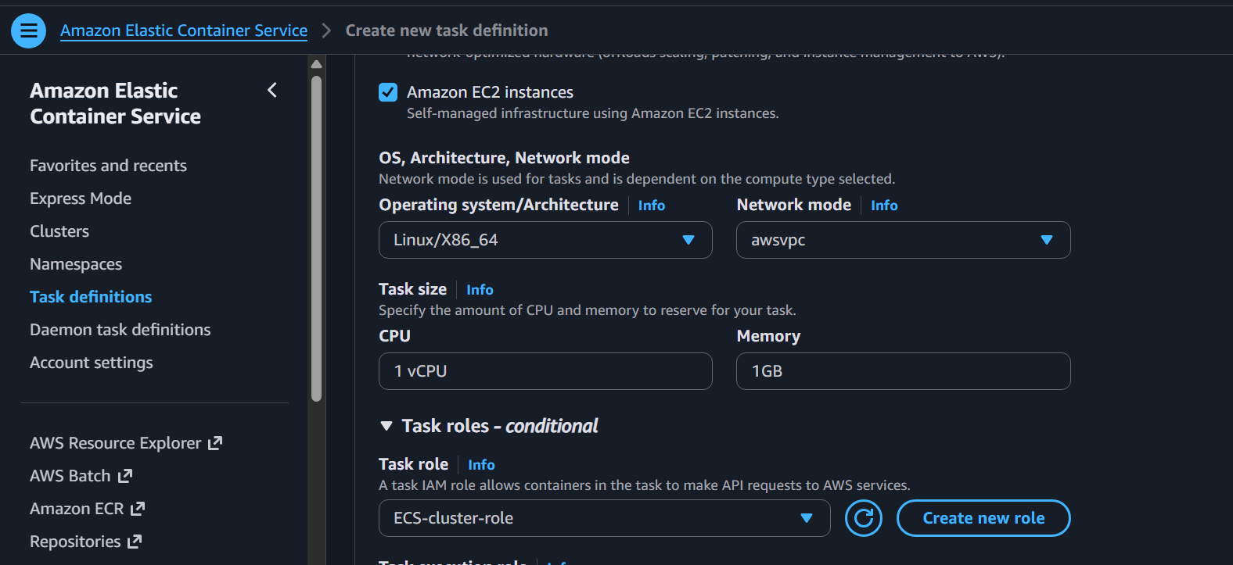
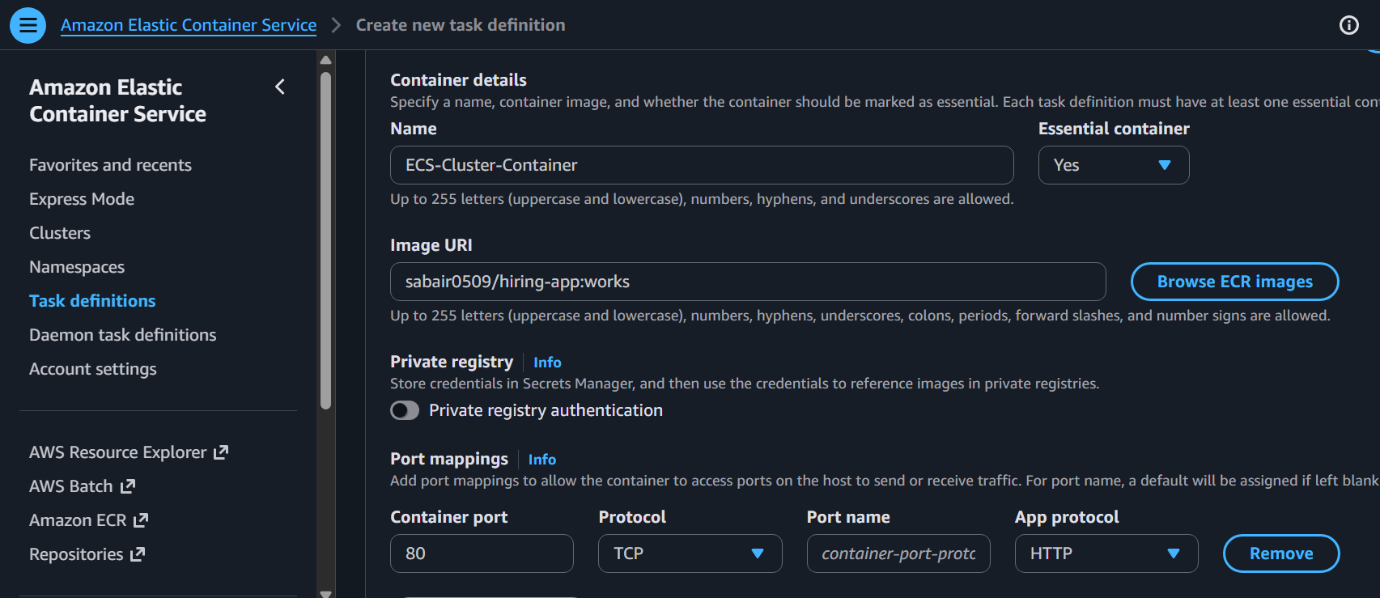
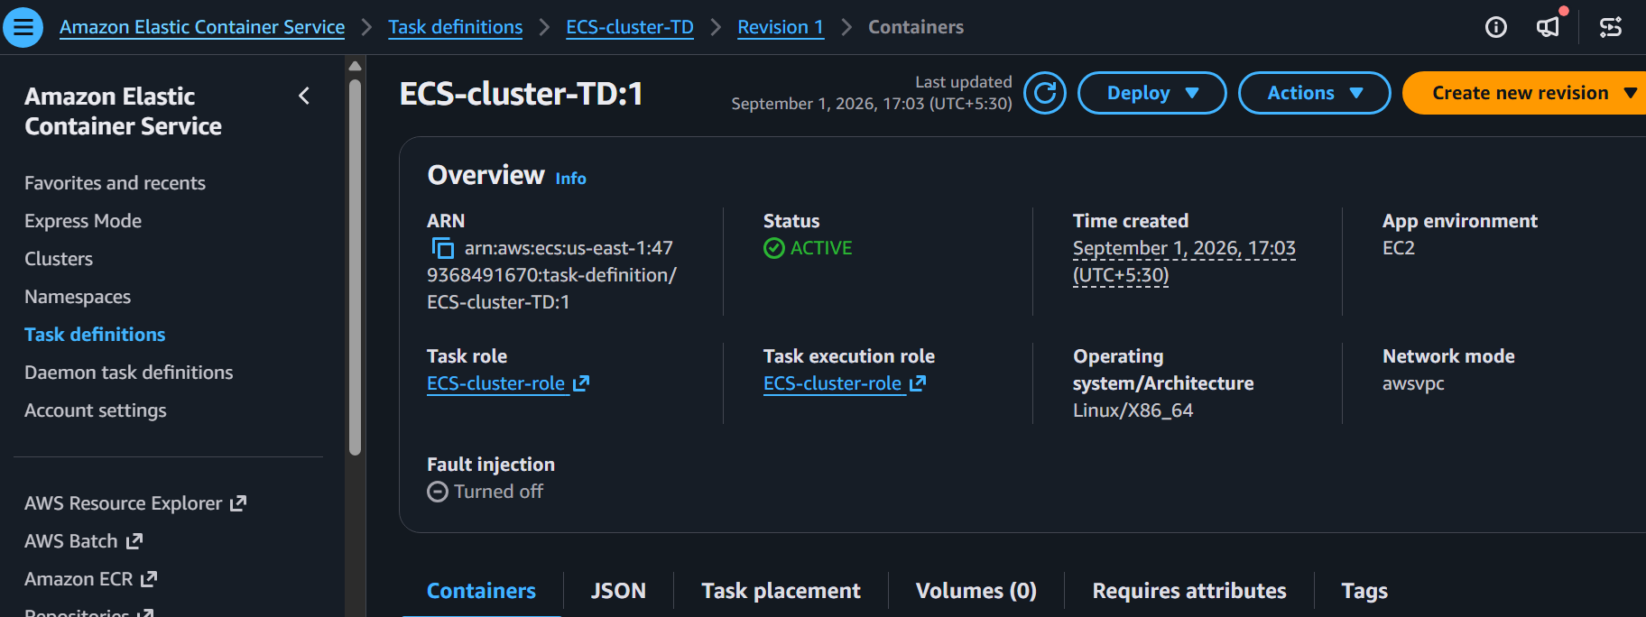
7. Configure Port Mapping
This is the dynamic port mapping requirement.
First, we need to know which port your hiring-app container listens on.
If it listens on 8080, configure:
Container port: 8080
Host port: 0
Protocol: TCP
The important part is: Host port = 0
Purpose: ECS automatically chooses an available host port.
8. Create ECS Service
Go to: ECS → hiring-app-cluster → Services → Create
Set: Service name: hiring-app-service
Task definition: hiring-app-task
Launch type: EC2
Desired tasks: 6
Purpose: ECS Service continuously maintains 6 running tasks.
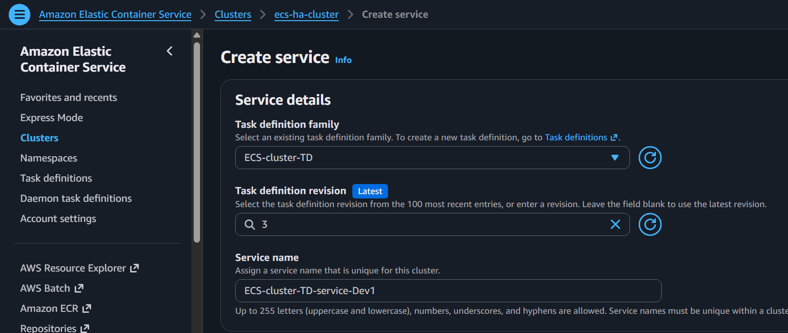
9. Attach Load Balancer
In the service configuration: Load balancer: Application Load Balancer
ALB: your ALB
Target group: hiring-app-tg
Container: hiring-app
Container port: 8080
Purpose: Connects your ALB to the hiring-app containers.
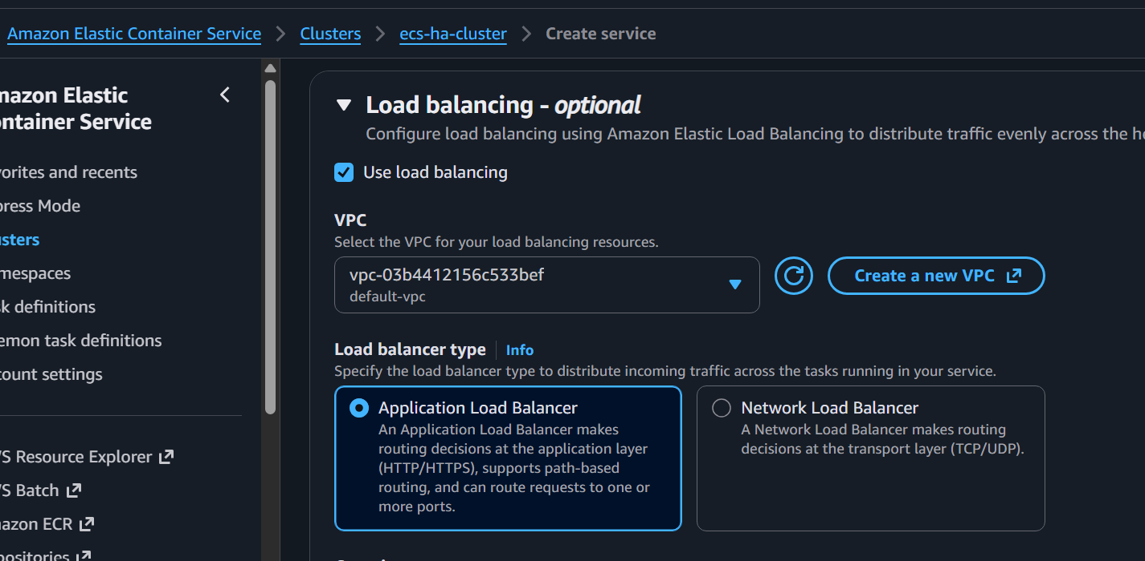
10. Configure Multi-AZ Placement
AWS Console → ECS → Clusters → Your Cluster → Services → Your Service → Update
Service configuration → Service deployment configuration → Task placement
Configure task placement to spread tasks across AZs.
Target:
AZ-1 → 3 tasks
AZ-2 → 3 tasks
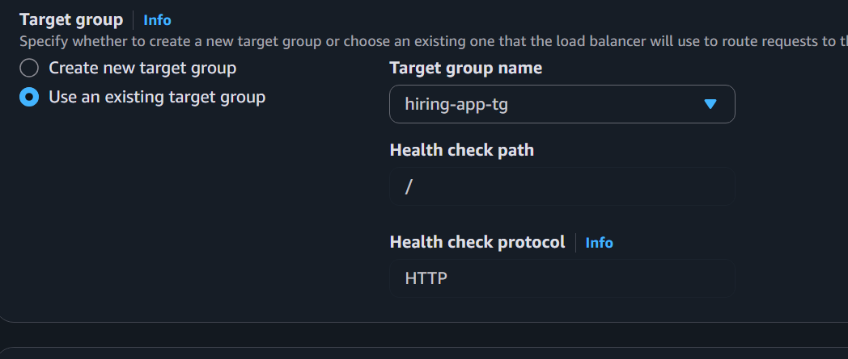
Purpose: Provides high availability if one Availability Zone fails.
11. Deployment Settings
Set: Minimum healthy percentage: 100%
Maximum percentage: 200%
Purpose: Keeps healthy application capacity available during deployments.
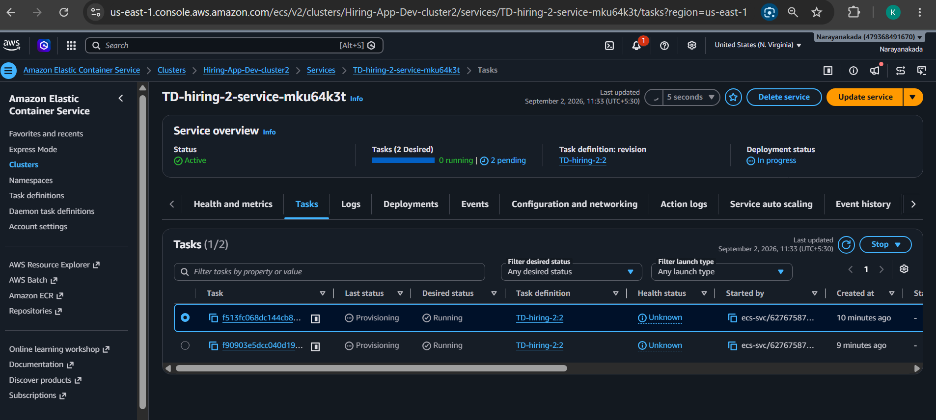
12. Create Service
Click Create Service.
Wait for:
Desired: 6
Running: 6
Pending: 0
13. Verify Target Group
Go to: EC2 → Target Groups → hiring-app-tg → Targets
You should see:
6 targets
6 Healthy
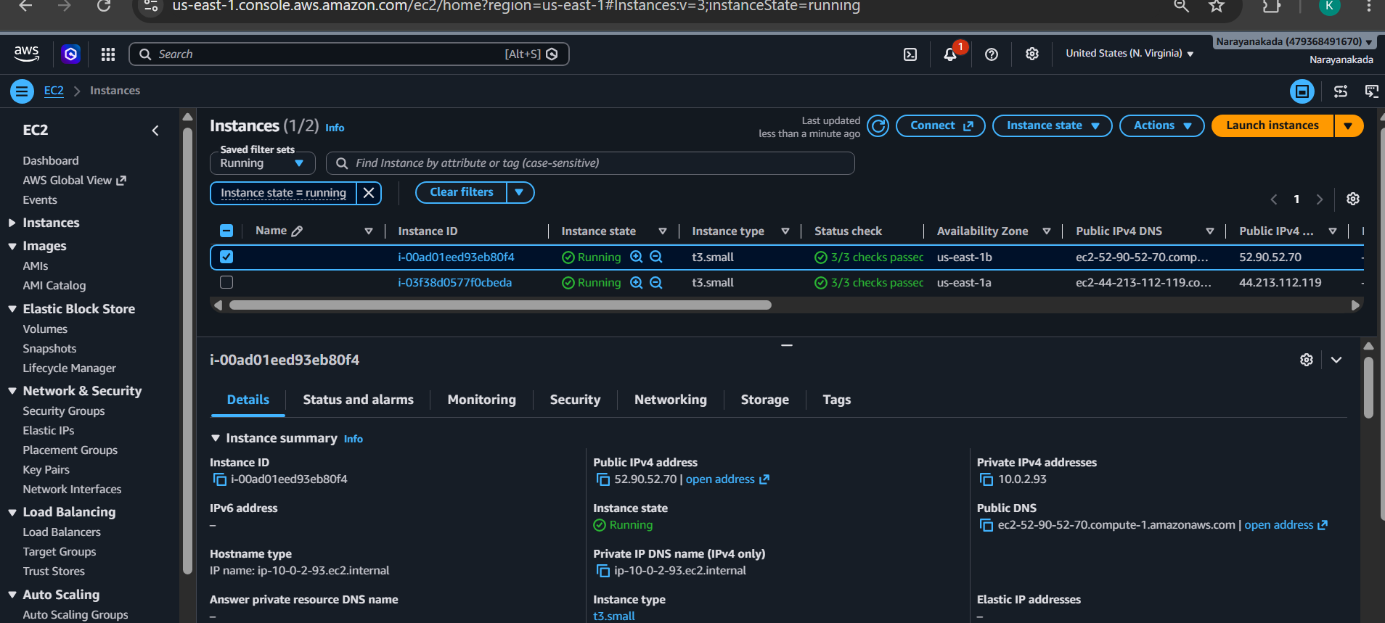
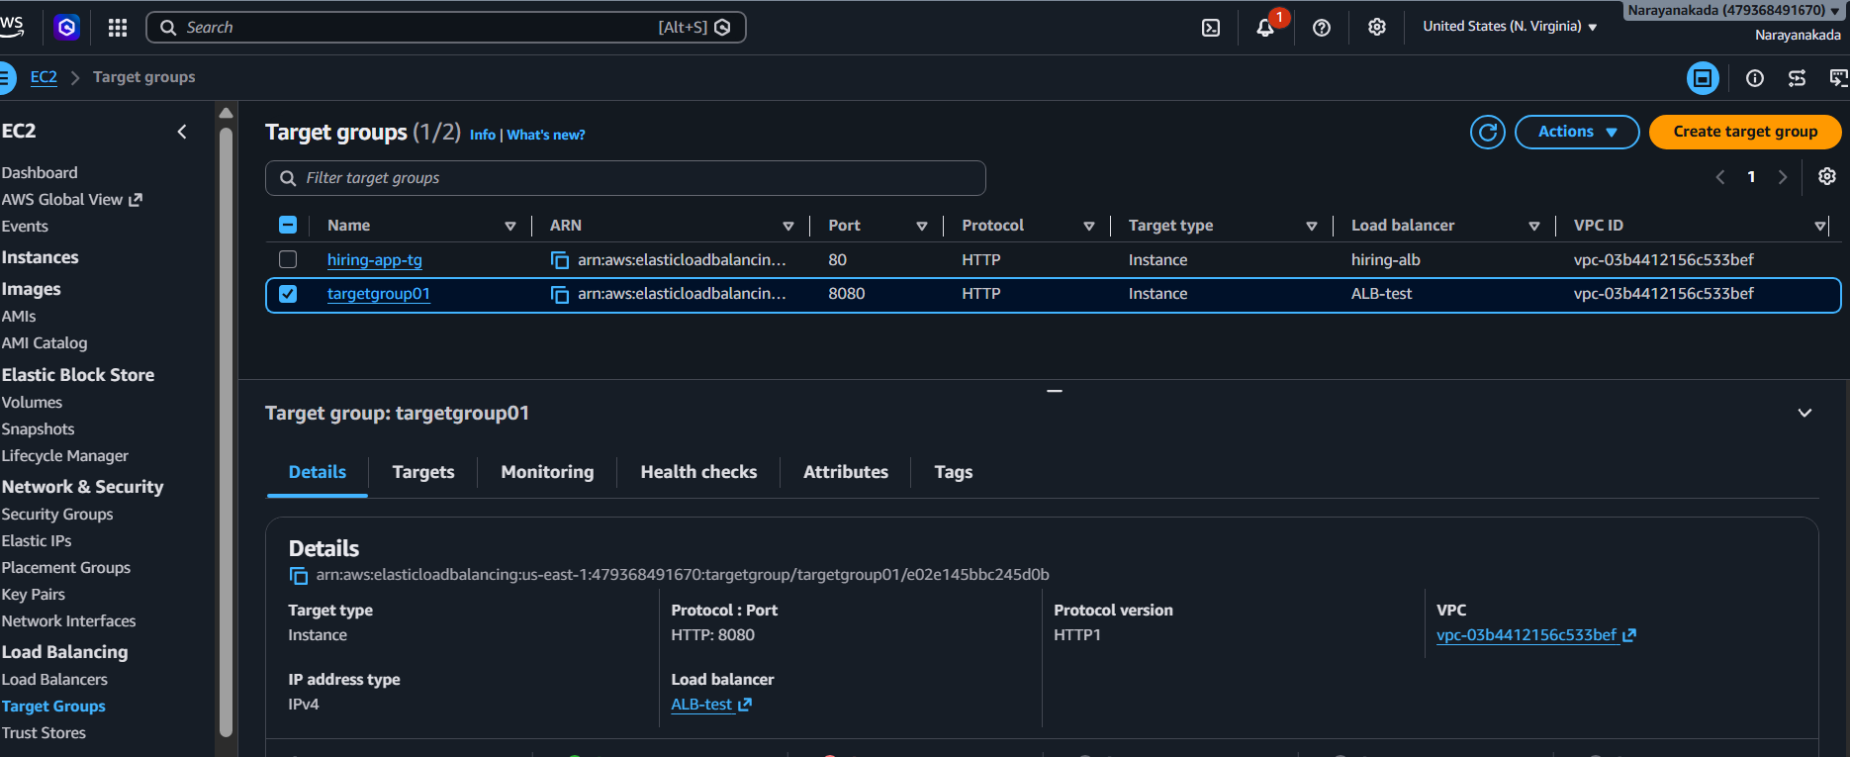
14. Test Application
Go to: EC2 → Load Balancers → your ALB
Copy the DNS name.
Open:http://<ALB-DNS>
Your flow will be:
Browser
↓
ALB :80
↓
Target Group
↓
Dynamic Host Port

